**SURYADATTA COLLEGE OF MANAGEMENT**

**INFORMATION RESEARCH & TECHNOLOGY**

**BAVDHAN, PUNE - 411021**

**CS-505-MJP: Lab Course on CS-502-MJ**

**(Artificial Intelligence)**

**Submitted by**

* **NAME OF STUDENTS ROLL NO**

1. **Mayank Parihar 2023100311**

**Under the Guidance of**

**Mr. DEEPAK SINGH**

**SUBMITTED IN PARTIAL FULLFILLMENT OF MASTER OF SCIENCE (COMPUTER SCIENCE)**

**SEM-I**

**SAVITRIBAI PHULE PUNE UNIVERSITY**

**For Academic Year 2023-2024**



**CERTIFICATE**

**This is to certify that Mr./Ms._______________________________­__**

**student of MSC(CS) Semester_________ having Seat No. _______________at Suryadatta College of Management Information Research & Technology (SCMIRT), Pune, has successfully completed the assigned practical in _____________________________ prescribed by the Savitribai Phule Pune University during the academic year__________________.**

**Internal Examiner External Examiner**

**Principal**

**Place: Pune**

**Date:**

14.Create an HTML5 program for the following input type

a. Date time

b. email input type

c. search input type

Sol)

!DOCTYPE html>

<html lang="en">

<head>

<meta charset="UTF-8">

<meta name="viewport" content="width=device-width, initial-scale=1.0"> <title>HTML5 Input Types</title>

</head>

<body>

<h2>Date Time Input</h2>

<label for="datetime">Select a date and time:</label>

<input type="datetime-local" id="datetime" name="datetime">

<h2>Email Input</h2>

<label for="email">Enter your email:</label>

<input type="email" id="email" name="email"

placeholder="example@example.com">

<h2>Search Input</h2>

<label for="search">Search:</label>

<input type="search" id="search" name="search" placeholder="Enter search term">

</body>

</html>

OUTPUT

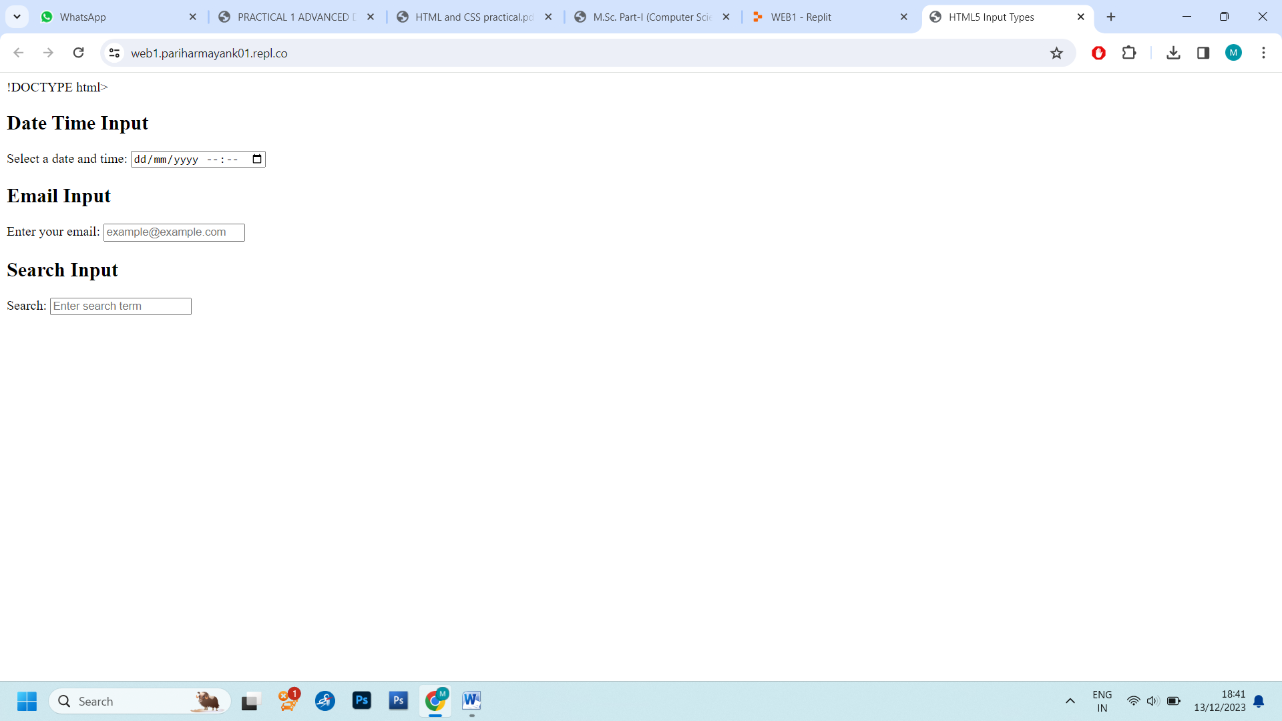

15.Write an HTML 5 program for student registration for college admission.

Sol)

<!DOCTYPE html>

<html lang="en">

<head>

<meta charset="UTF-8">

<link rel="stylesheet" href="highlight.css">

<title>College Admission Registration</title>

<style>

body {

font-family: Arial, sans-serif;

margin: 20px;

}

form {

max-width: 600px;

margin: 0 auto;

}

label {

display: block;

margin-bottom: 5px;

}

input,

select {

width: 100%;

padding: 8px;

margin-bottom: 10px;

box-sizing: border-box;

}

button {

background-color: #4CAF50;

color: white;

padding: 10px 15px;

border: none;

border-radius: 5px;

cursor: pointer;

}

</style>

</head>

<body>

<h2>Student Registration for College Admission</h2>

<form action="#" method="post">

<label for="fullName">Full Name:</label>

<input type="text" id="fullName" name="fullName" required>

<label for="dob">Date of Birth:</label>

<input type="date" id="dob" name="dob" required>

<label for="gender">Gender:</label>

<select id="gender" name="gender" required>

<option value="male">Male</option>

<option value="female">Female</option>

<option value="other">Other</option>

</select>

<label for="email">Email:</label>

<input type="email" id="email" name="email" required>

<label for="phone">Phone Number:</label>

<input type="tel" id="phone" name="phone" required>

<label for="highSchool">High School Name:</label>

<input type="text" id="highSchool" name="highSchool" required>

<label for="graduationYear">Year of Graduation:</label>

<input type="number" id="graduationYear" name="graduationYear" min="1900" max="2100" required>

<button type="submit">Submit</button>

</form>

</body>

</html>

Output:

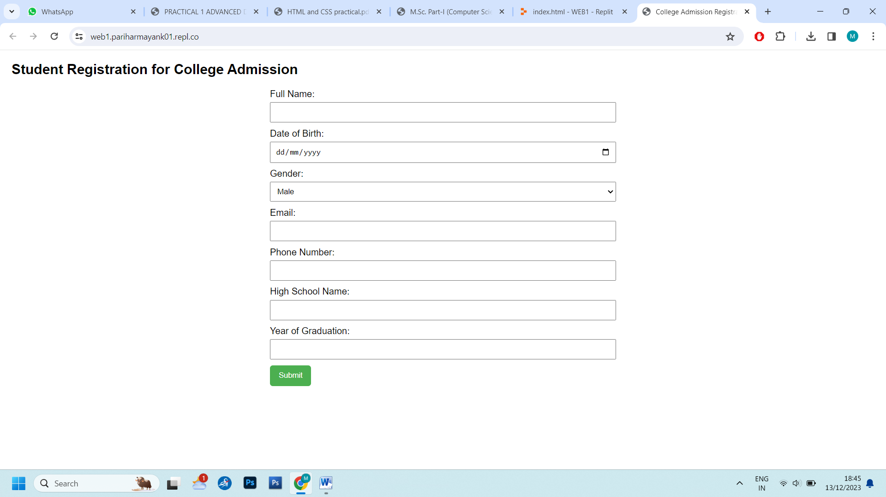

16.Write a css3 script for the above student registration form

e.g. high lite compulsory fields in a different color

Sol)

body {

font-family: Arial, sans-serif;

margin: 20px;

background-color: aliceblue;

}

form {

max-width: 600px;

margin: 0 auto;

}

label {

display: block;

margin-bottom: 5px;

}

input, select {

width: 100%;

padding: 8px;

margin-bottom: 10px;

box-sizing: border-box;

}

button {

background-color: #cc3488;

color: white;

padding: 10px 15px;

border: none;

border-radius: 5px;

cursor: pointer;

}

input:required,

select:required {

border: 2px solid #e44d26; }

input:focus, select:focus {

outline: 2px solid #4CAF50;

}

button:hover {

background-color: #1f704a

}

OUTPUT:

